|  |
| --- |
| **Curriculum Vitae** |

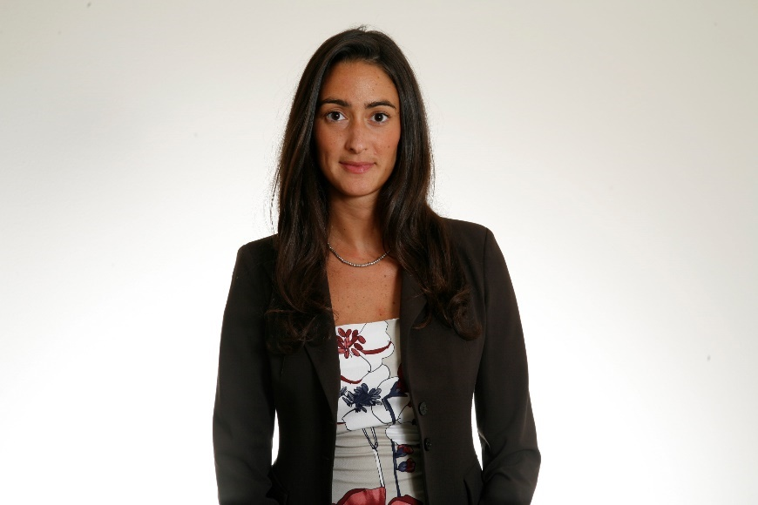

|  |
| --- |
| **Personal Information** |
| Name |  | **Maria Luigia Franceschelli** |
|  |  |  |
| **Education** |

|  |  |  |
| --- | --- | --- |
| • Dates |  | 2011-2015 |
| • Name and type of educational or training institution |  | **University of Milan** |
| • Principal subjects / occupational skills covered |  | Faculty of law |
| • Qualification obtained |  | PhD in Intellectual Property Law |
| • Level in national classification (if applicable) |  | Phd dissertation on “The protection of shape of industrial products: a comparative analysis” |
| • Dates |  | 2005-2010 |
| • Name and type of educational or training institution |  | **University of Milan** |
| • Principal subjects / occupational skills covered |  | Faculty of law |
| • Qualification obtained |  | Degree in Law |
| • Level in national classification (if applicable) |  | Degree dissertation in Intellectual Property Law with Prof. G. Ghidini.  "'The protection of shape of industrial products: a comparative analysis (UK,USA and Italy)".  110/110 cum laude. |
|  |  |  |
| • Dates |  | September 2007 - March 2008 |
| • Name and type of educational or training institution |  | **University of Barcelona.**  Exchange Student – Erasmus Programme |
| • Principal subjects / occupational skills covered |  | Intellectual Property Law |
|  |  |  |
| • Dates |  | August 2009 – December 2009 |
| • Name and type of educational or training institution |  | **University of California, Berkeley.**  Boalt Hall – Law School |
| • Principal subjects / occupational skills covered |  | Copyright law and Patent law |
|  |  |  |
| **Education** |  |  |
|  |  |  |
| • Dates |  | May 2015 |
| • Name and type of educational or training institution |  | **Fordham Law School, New York** |
| • Principal subjects / occupational skills covered |  | Course in Fashion Law |
|  |  |  |
| • Dates |  | 2019 |
| • Name and type of educational or training institution |  | **UPA (Utenti Pubblicità Associati - Associated Advertising Users)** |
| • Principal subjects / occupational skills covered |  | Course on Commercial Communication Law |
|  |  |  |
| **Languages known** |
| Mother tongue |  | **Italian** |
| Other language |  | **English** |
| - Reading skills |  | Excellent |
| - Writing skills |  | Excellent |
| - Oral expression skills |  | Excellent |
| Other language |  | **Spanish** |
| - Reading skills |  | Good |
| - Writing skills |  | Sufficient |
| - Oral expression skills |  | Sufficient |
|  |  |  |
| **Current position** |
| **•** Dates (from – to) |  | From June 2011 – today |
| **•** Name and address of employer |  | **Hogan Lovells Studio Legale**  Via Santa Maria alla Porta 2, Milan |
| **•** Company or sector |  | Law Firm |
| **•** Type of employment |  | Counsel (since 2023) |
| **•** Main duties and responsibilities |  | Out-of-court and in-court assistance in advertising, unfair competition, trademarks, patents, designs and copyright; and, in particular, drafting of contracts, briefs, assessments, strategic opinions, cease and desist letters and settlements; enforcement activities; due diligence activities; clearance, opposition proceedings. |
| **Bar admission** |  | Milan, 2013 |
| **Work experiences** |
| **•** Dates (from – to) |  | March 2018 – December 2018 |
| **•** Name and address of employer |  | **Guccio Gucci S.p.A.** |
| **•** Type of employment |  | Secondment – licensing and communication department |
|  |  |  |
| **•** Dates (from – to) |  | April 2016 – July 2017 |
| **•** Name and address of employer |  | **Bottega Veneta S.r.l.** |
| **•** Type of employment |  | Secondment – licensing and communication department |
|  |  |  |
| **•** Dates (from – to) |  | January 2011 – April 2011 |
| **•** Name and address of employer |  | **Italian Embassy at Kuala Lumpur** |
| **•** Type of employment |  | Stage – MAECI-MIUR-CRUI |
|  |  |  |
| **•** Dates (from – to) |  | March 2009 – June 2009 |
| **•** Name and address of employer |  | **Assicurazioni Generali S.p.A. – London office** |
| **•** Type of employment |  | Stage |
|  |  |  |

|  |
| --- |
| **Further information** |
|  |  |  |
|  |  |  |
| Activities |  | * Throughout the PhD, assistance to Prof. Gustavo Ghidini in the Intellectual Property law course at the University of Milan, actively collaborating in the management and organization of the course and collaborating as lecturer. * Currently, assistant at the University of Milan. * Lecturer at the conference entitled "IP and fashion: from creator to consumer," May 29, 2019, University of Milan * Associate Professor at the Uninettuno Telematic University, Master in Fashion law, Digital law module (2022) * Lecturer at the Master in Business Administration of the University of Milan- Bicocca (2020-2021-2022) * Lecturer at the Master in Fashion Law at Luiss University of Rome (a.y. 2019/2020, 2020/2021, 2021/2022) * Lecturer at Giuffrè's Fashion Law Specialization Course (a.y. 2018-2019) * Member of the editorial board of the Rivista di Diritto Industriale (Journal of Industrial Law) * Contributor with case-law abstracts for the website Giurisprudenza delle Imprese (Caselaw of companies) * Founder of the blog IPLens * Contributor with case-law abstracts for the journal: Sez. Spec. della Propr. Ind. 2012 (Specialized Sections of Intellectual Property 2012) |
|  |  |  |
| Prizes and Awards |  | * 2019 - Industry Focus: Luxury Goods / Legal 500 EMEA * 2021- Key Lawyer in Intellectual Property / Legal 500 EMEA * “Maria Luigia Franceschelli has extensive and effective training in the field of IP and communication issues. It is able to support the business with speed and focused responses” - Legal 500 EMEA 2021 * Managing IP Rising Star 2020, 2021 and 2022. |
| Publications on the press  and events |  | * “Foul play - first enforcement of Italian Decree on ambush marketing” published on Engage on 9 May 2022; * Interview of 14 March 2022 "Fashion: Hogan Lovells,'Russia could become huge market for counterfeit products" published in Adnkronos and various magazines (Il Foglio); * Interview of 21 February 2022 "Metaverse Lawyers in the field to defend fashion also in the metaverse" published in Il Sole 24ore; * Interview of 29 January 2022 "Chiara Ferragni, a valuation for the brand between 80 and 160 million" in Milano Finanza and MFFashion; * Lexology’s “Getting the Deal Through: Luxury & Fashion“ for Italy (she is directing the drafting and updates since 2020, together with Luigi); * HL Holiday Guide 2021; * Article on the Fendace collection published in November 2021 on MF Fashion; * Article in November 2021 'The success of luxury brands in the hospitality sector in the Middle East' published in DDN; * Webinar on influencer marketing (IP, tax and employment issues) held on 27 May 2021; * Article on Green IP published in March 2021 on Managing IP; * Article on the Ferragnez phenomenon published in March 2021 on Milano Finanza; * “Augmented reality and e-commerce: IP implications of a powerful alliance” article published on Engage on 16 December 2020; * HL Webinar on “Influencer Snapshot webinar series: Influencers around the world“ (Italy, China and US) held on 24 September 2020; * Italy introduces changes to historical trademarks of national interest published on Engage on 17 August 2020; * Converting your production to make masks and disinfectants? Our legal guide for Italy published on Engage on 21 May 2020; * Lecture at Assolombarda on influencer marketing in February 2020 (together with the SOAR group); * Article for the holiday guide 2019 The holiday shopping rush is here – Eight things retailers need to know this season, published on Engage on 6 December 2019; * Influencer Snapshot: Getting a handle on social media influencers published on Engage on 5 December 2019; * Event on the protection of hashtags (“No more hashtag drama”) organized at Talent Garden together with a team of associates in 2017; * Since 2018, speaker at the HL annual event with students of the ELSA organization. |

13 October 2022